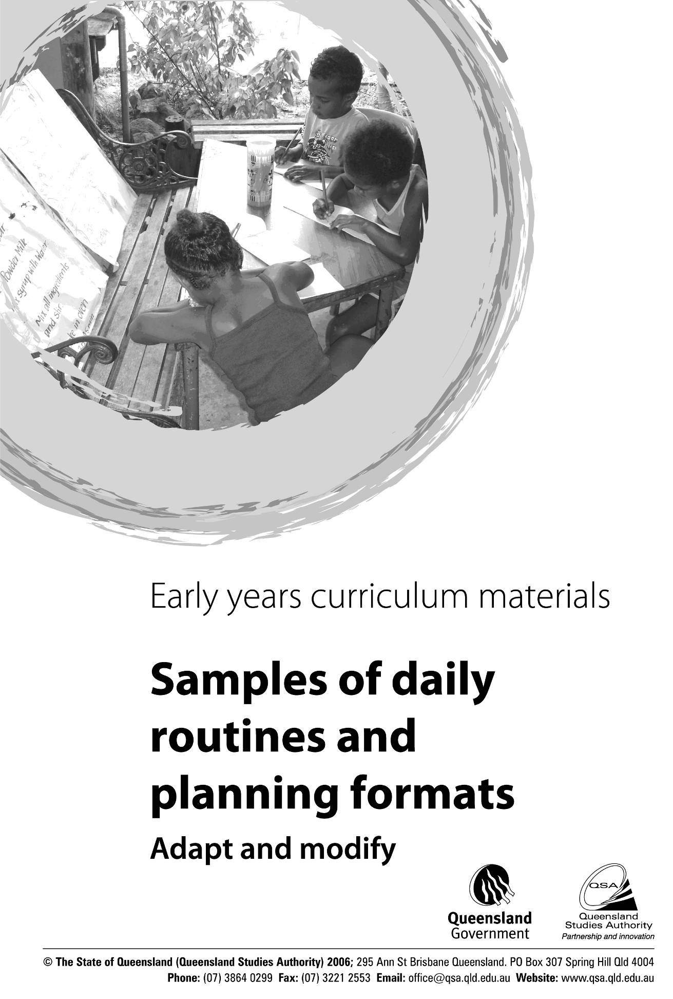

This support material
How does a typical day of a Prep Year gradually change as the year progresses?
How is time managed to ensure that children experience both outdoor and indoor experiences?
How can you ensure that the day remains flexible so that children’s shifting interests and ideas are incorporated into the learning program?
How can you manage time to balance longer periods of active learning with routines such as meal breaks, rest/relaxation/quiet activities, and shorter periods of time for small and large group learning opportunities?
How can you use teacher-aide time most effectively — interacting with children, helping with the preparation of materials and cleaning up after active outdoor or indoor learning sessions?
What other staff could help with setting-up or packing away heavy outdoor equipment if the teacher aide starts after 9.00 am?
Are there groups of children (e.g. after/before school care or older students) who could support the program by cleaning paint pots, paint brushes or setting up resources for the next day?
How can you incorporate specialist lessons in ways that are meaningful to children and connected to the Prep Year curriculum?
How can you manage non-contact/teacher-release time?
How can you manage staff to ensure that the teacher and teacher aide have meal breaks?
How can you ensure adequate safety and supervision during outdoor play?
How can you manage the day when the Prep Year class needs to share the playground space with other year levels?
How can you manage the day when toilet facilities for adults and children are external to the classroom?

The examples highlight
The importance of active “hands-on” learning that engages children emotionally, socially, intellectually and physically rather than formal, teacher-directed learning that requires children to be passive learners
gradual shift from a stronger focus on child-initiated play-based learning, to a program that also includes teacher-child negotiated learning, and teacher-initiated focused learning and teaching
need to consider safety and supervision
need to incorporate all five contexts for learning and development
importance of allocating longer blocks of time for active play-based learning, real-life situations and investigations, and shorter amounts of time for focused learning and teaching involving small or larger groups.
need to work collaboratively with partners from the school staff (grounds support staff, other teachers, etc.), parents/ careers and teacher aides to ensure that the outdoor and indoor areas are set up and cleaned up during the day, and teacher aides spend the majority of their time interacting with children.

need to work collaboratively with partners from the school staff (grounds support staff, other teachers, etc.), parents/ careers and teacher aides to ensure that the outdoor and indoor areas are set up and cleaned up during the day, and teacher aides spend the majority of their time interacting with children.
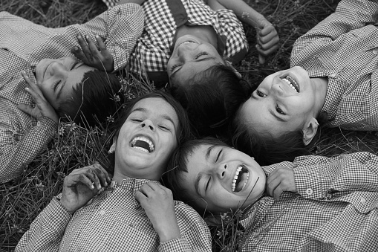 How can you manage time to balance longer periods of active learning with routines such as meal breaks, rest/relaxation/quiet activities, and shorter periods of time for small and large group learning opportunities?

